**Steps for Viewing & Validating a MIDE Master Reference Data Tables in the Ab Initio Metadata Data Hub**

1. From the **Ab Initio Metadata Data Hub home page**, select the **Domains** option.

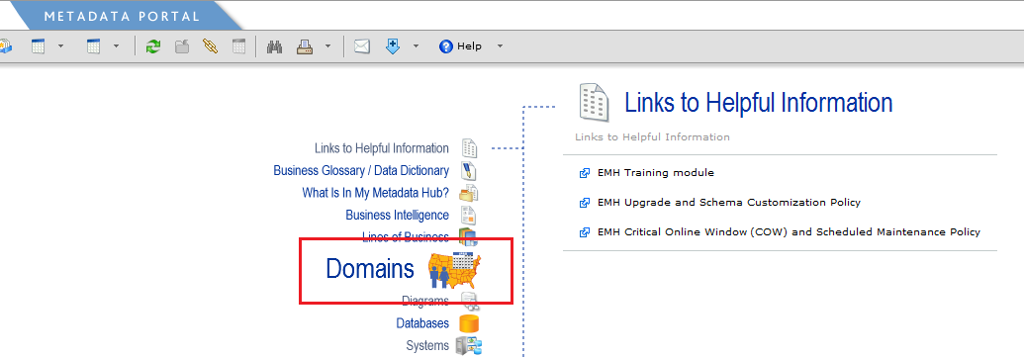

1. The **Domains** page will appear and you will see some search options as well as an alphabetical list of tables. The MIDE Reference Data Tables will end with a suffix of “**CL.HL**” which represents Consumer Lending.Home Lending.

In this example, we will view the CONST_TYPE (Construction Type) reference table.

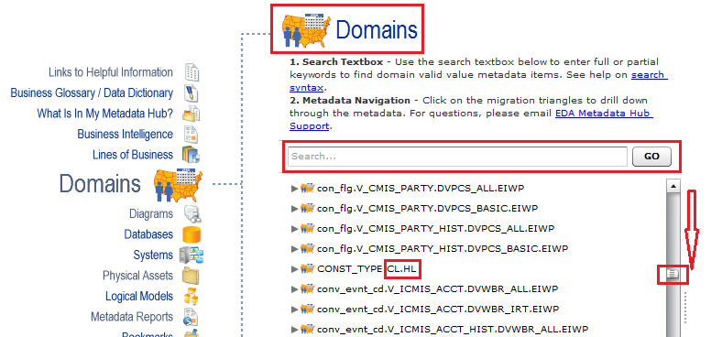

1. The **Details for Domain** page will open on the **Info** tab and it verifies the reference table name that has been selected. The actual domain values will appear on the **Master Values** and **Encoding** tabs.

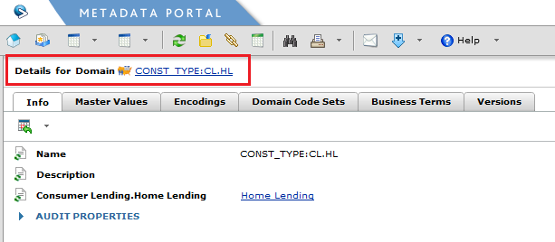

1. After selecting the **Master Values** tab you will see the details for the CONST_TYPE MIDE Master Reference Data Table. The **Name** column provides a concatenation of the **MIDE Master Type Code Value** followed by the **MIDE Master Type Code Name**.

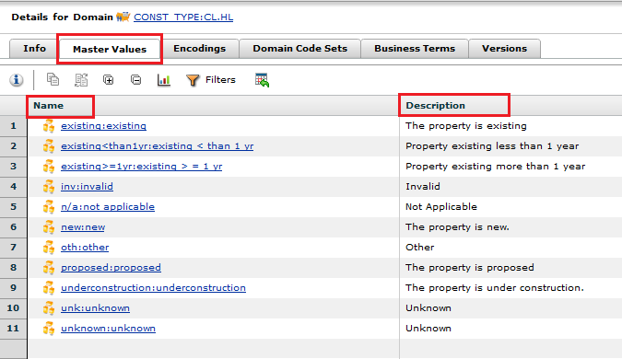

1. The **Encodings** tab provides a valuable view into the System of Record (SOR) code values that are mapped to the MIDE Master Type Code Values. Tin this example, the **Master Value** column identifies the seven concatenated MIDE Master Type Code Values & Names that were created based on the SOR reference code value sets associated with this reference data table. The last four code values are default **MIDE Master Type Code Values** (Invalid, Not Applicable, Other, and Unknown) that are used in every MIDE Master Reference Data Table.

To the right of the MIDE Master Values columns you will see the applicable SORs and their respective reference data values that are mapped to each MIDE Master Value. In this example, we see that we are mapping of reference data code values from AS400, CORE, LIS, and LPS that are associated with the MIDE CONST_TYPE Reference Data Table.

**Note:** Only SOR type code values that have a Record Status Code of “A” (Active) in the MIDE Reference Data Table mapping document will appear in the Ab Initio Metadata Data Hub. Records with a Record Status Code of “I” (Inactive) or “N” (New) will not appear.

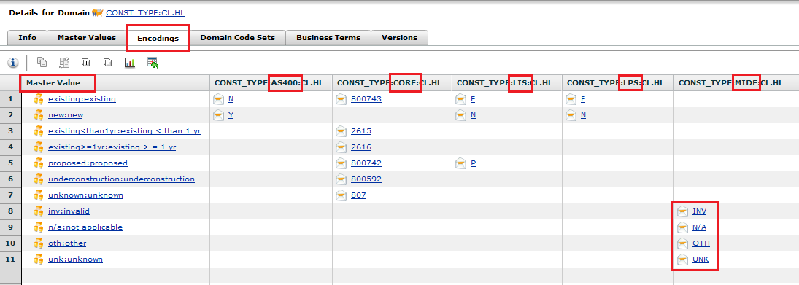

You are now able to view and validate a MIDE Master Reference Data Table in the Ab Initio Metadata Data Hub.